Lab 12: Rolling Motion – Moment of Inertia
By: Dr. D. Beznosko
For PHYS 2211L, PHYS 1111L
06/30/2022
(Lab outcomes: Test Tracker skills. Measure radius in Tracker)

Abstract
The Tracker-based assignment Rolling motion – moment of inertia is aimed at testing the student mastery of Tracker software and understanding of the independent analysis and necessary steps that were used throughout the semester. Therefore, minimal instructions are provided with no additional support if the information was already present in any of the previous manuals.

Introduction
This experiment is from the Tracker series labs. The moving body in an incline plane experiences the acceleration that is defined by several factors. One of them is the angle of the include, and another is the force of friction. However, if the body is not sliding but rolling, the work of friction converts into the rotation of the body. What characterizes the rotation is the moment of inertia of the body that in some sense replaces the mass in the equations. Hint – you can provide some background information on the physics behind the motion on the incline plane, moment of inertia, where is it used and any other relevant information.

Experimental Setup
For this experiment, use the high frame rate video provided. You could consider making your own video using lab equipment if you have a high-speed camera (at least 480 fps). Discuss this option with instructor if interested.
The setup schematic is outlined in Figure 1 and consists of the ruler for scale, inclined plane, and a ball on the plane. Consider describing the screenshot instead with all tools visible, such as axes, protractor and calibration stick.
Ruler
Inclined plane
Ball
Figure 1: The experimental setup schematic for shooting the video. (a) ruler used to set the scale, (b) ball launcher.

Procedure:
Download all files provided. Make sure it’s not a zip archive (unzip if necessary). There should be five video files, two image files and this manual.
Set the frame rate as indicated in the video file name.
Set the scale as usual. Use the protractor to measure the angle – there is a vertical yellow rope with a bob that gives a sense of vertical direction. Hint – for simplicity, you can align the vertical axis or coordinate system with this rope and measure the angle (with errors!). You may need to do the 180-value if its >10, or multiply by -1 if negative. Angle should be <90º and positive.
Choose to have the coordinate system origin at any location that is convenient, like the initial position of the ball… Align the x-axis with the inclined plane.
Set the start point to the first frame where the ball is fully visible.
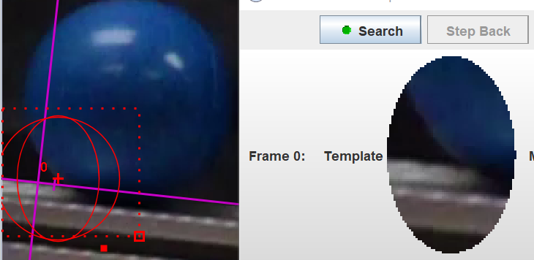
Create a new point mass, set the footprints to circle, and choose a good size and place. Do a test run to make sure that the ball is actually tracked all the way down. If tracking breaks down along the way, you can either track 2-3 frames manually (See tutorial video on tracker. Can also skip or accept, but make sure the data quality doesn’t suffer.) or choose another spot to track. The recommended spot for tracking is the lower left part of the ball.
Choose to track every x^{th} frame based on your assessment of this video and performance of your computer. Mention this in your report as well as the reason for the setting. Do the tracking.
Fit the plot $xvst$ with a (this is a motion under acceleration, which curve should you use?) and write down the $a_{x}$ with its error from the fit. This is the statistical error. Don’t close the fit window yet. Assess the systematic error as well in a usual way. Show this work done. Combine both errors into a single one.
Analyze all 5 videos. You should end up with five pairs (angle, acceleration) in your data.

Theory
For any symmetric rotating body, the moment of inertia is essentially expressed as
$$I=C∙MR^{2}\left(1\right)$$
where C is the geometric distribution of mass $M$ in a body of radius $R$. We can use this fact to simplify the equations of motion for this ball on the inclined plane.
(PHYS2211L must include derivation, for PHYS 1111L its extra points) Show the derivation of the equation 2 starting from the free body diagram and the forces acting on the ball. Use equation 1 to simplify the answer and get to this result:
$$\frac{gsin\left(θ\right)}{a}=C+1\left(2\right)$$
$g$ here is the acceleration of free fall, $a$ is the acceleration of the ball and $θ$ is the incline angle of the plane. Do the plot such that the slope is $C+1$. For your vertical axis, you will need to use (PHYS2211L) the partial derivative method or (PHYS1111L only) the error estimation method so that you can propagate the error on theta over the sine function. Reminder for derivative taking– $Δθ$ must be in radians.

Analysis
Highlight the process of fitting and getting fit parameters and fit quality. Provide the results. Find the value of $C$. Compare this value within errors to the Figure 2. Does the ball seem to be a solid sphere, a shell or anything else?
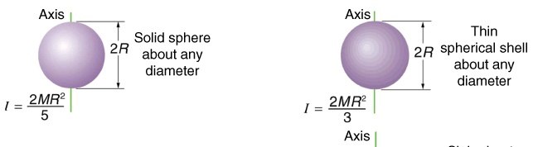
Figure 2: Moments of inertia for two spherical masses.

Conclusion
Comment on the measured result and your conclusion about the ball. Do you think your result is accurate? Support this with some argument, perhaps using a plot and points distribution. What could be the reasons for that? Any comments and improvements?

